**Azure Databricks Coding Assessment**

1. **Exploratory Data analysis (EDA) in Databricks &Visualizing data in Databricks.**

* Exploratory data analysis (EDA) helps us to explore data sets and also to summarize the main characteristics of datasets.
* It helps to identify any problems with the data.
* Databricks has built-in analysis and visualization tools in both Databricks SQL and in Databricks Runtime.

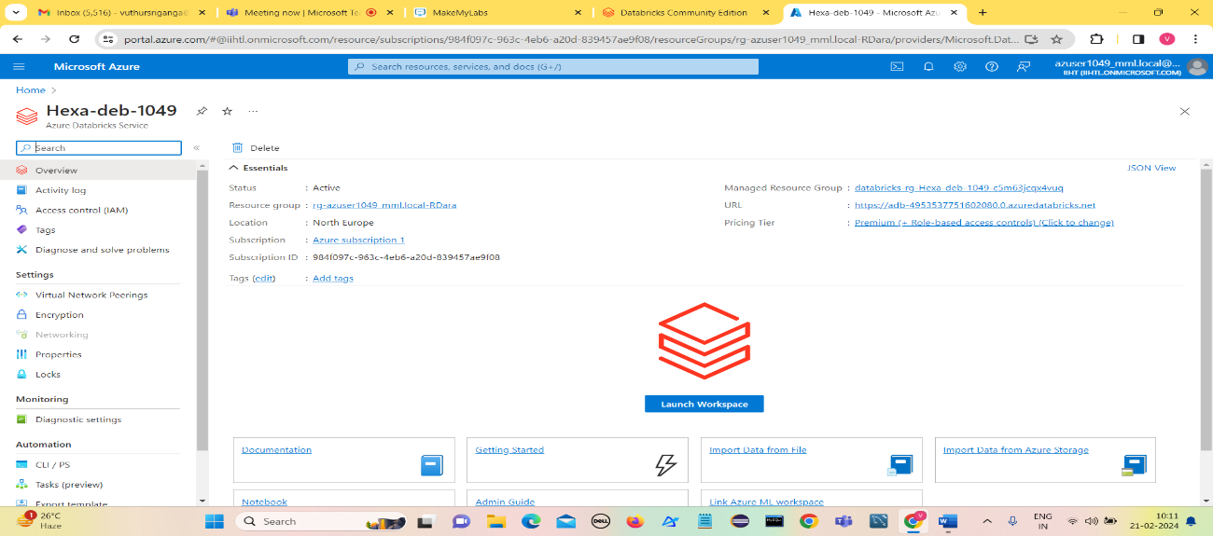**Visualising data using Exploratory Data Analysis.**

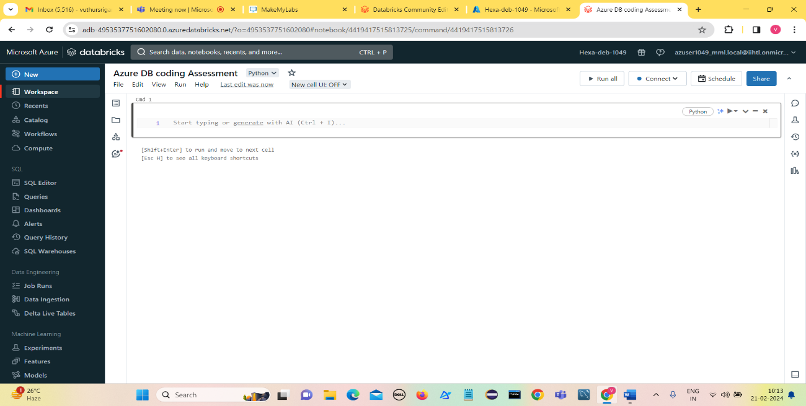**Create a Azure Databricks service and Click on Launch WorkSpace.**

**Create Compute**

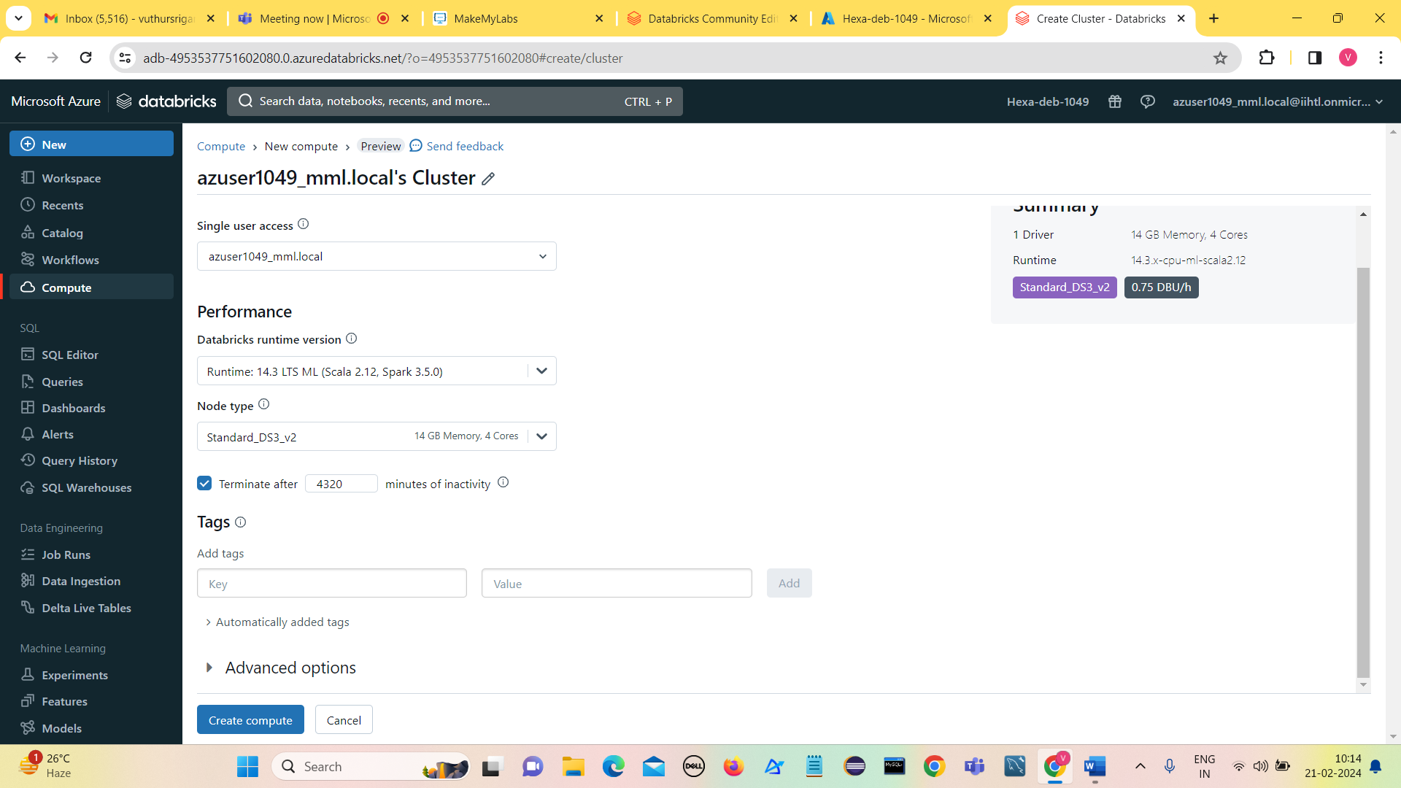

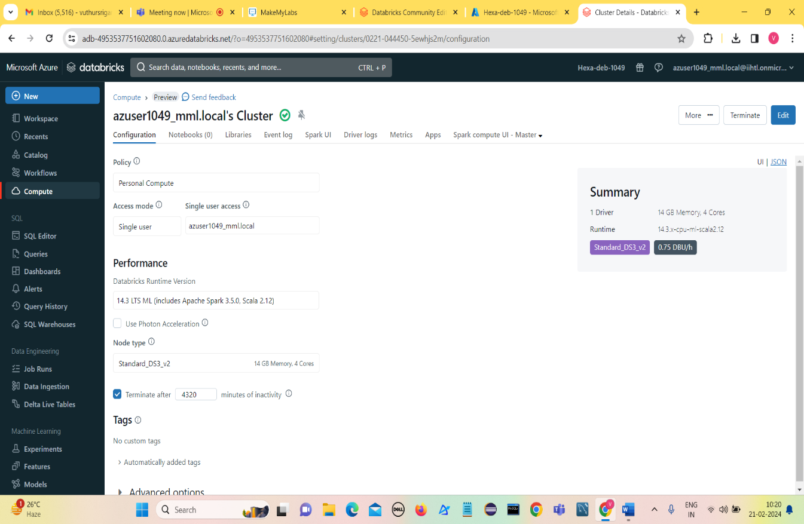**Compute got created.**

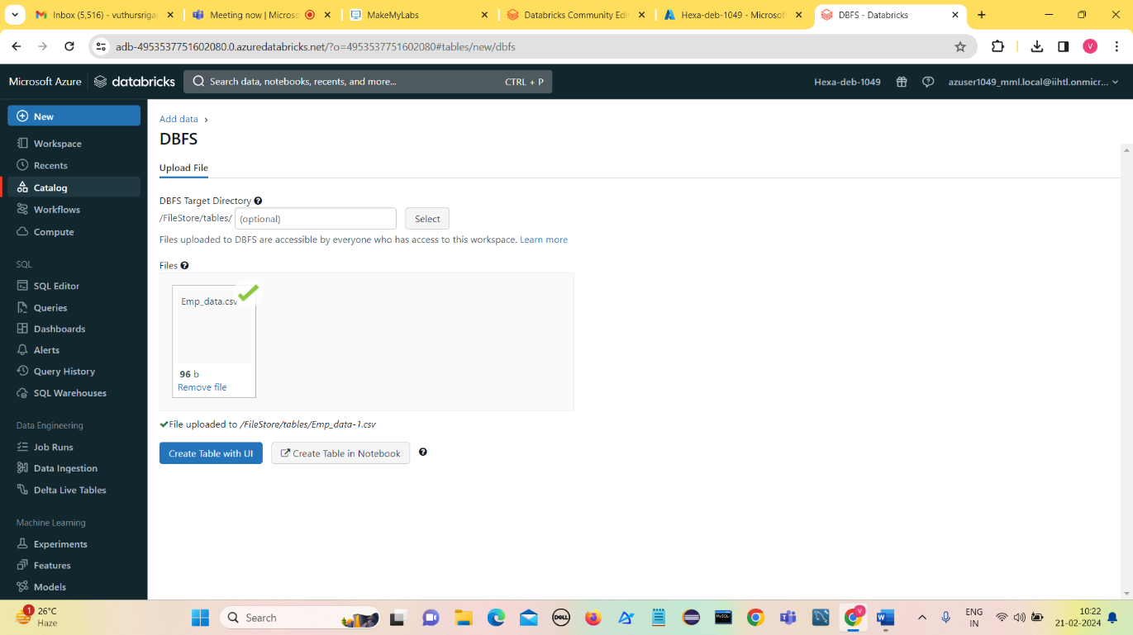**Go to catalog and create a table.**

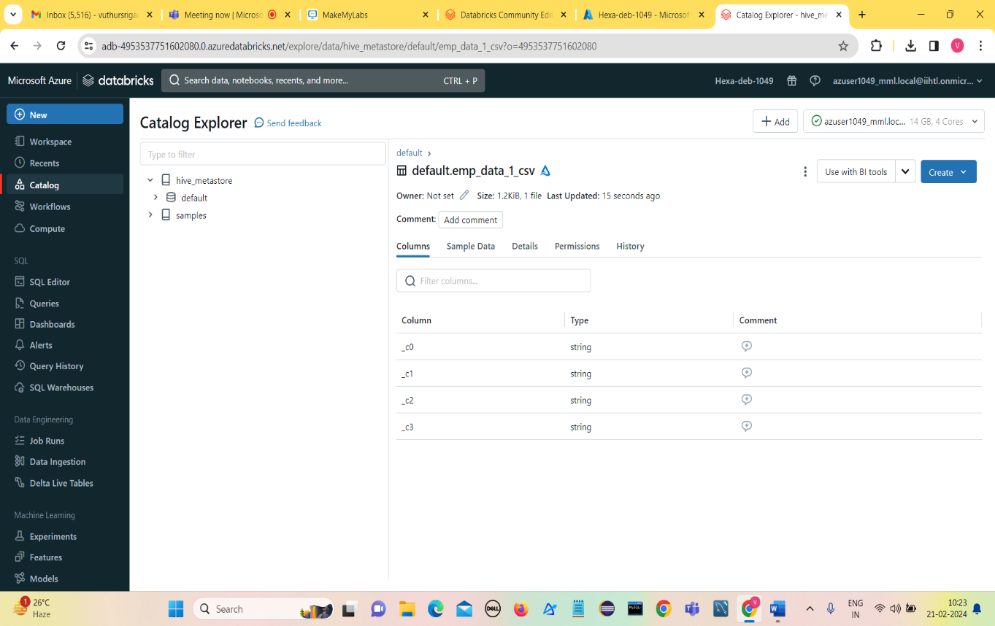

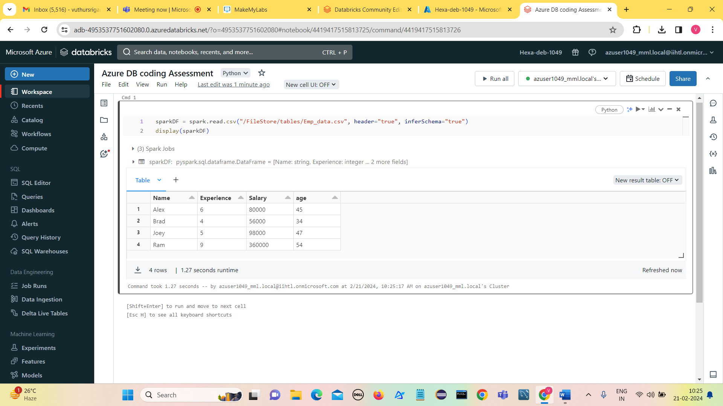

**Visualization Types:**

1. 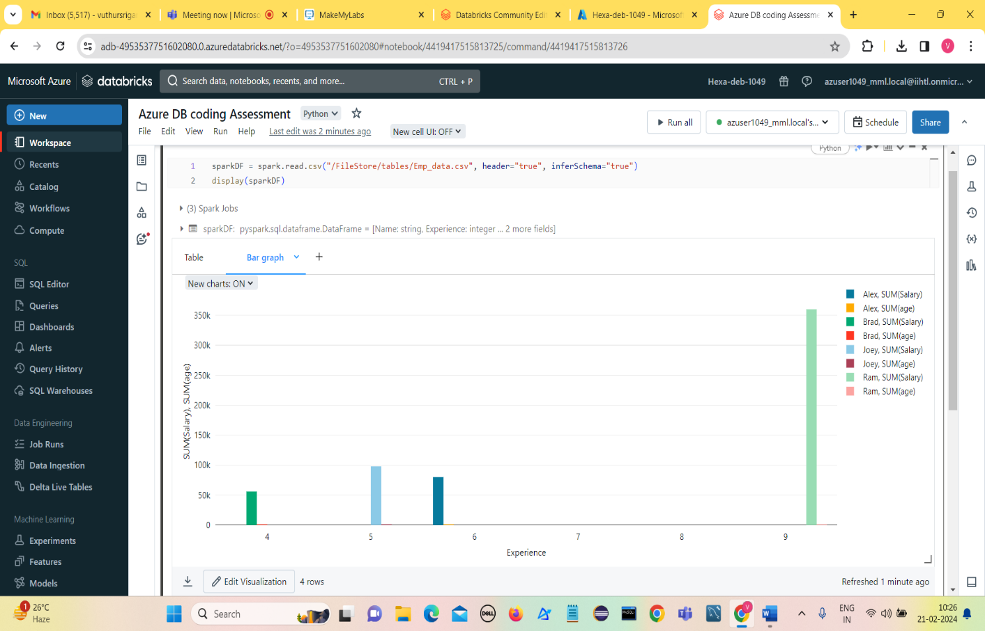**Bar Chart**
2. 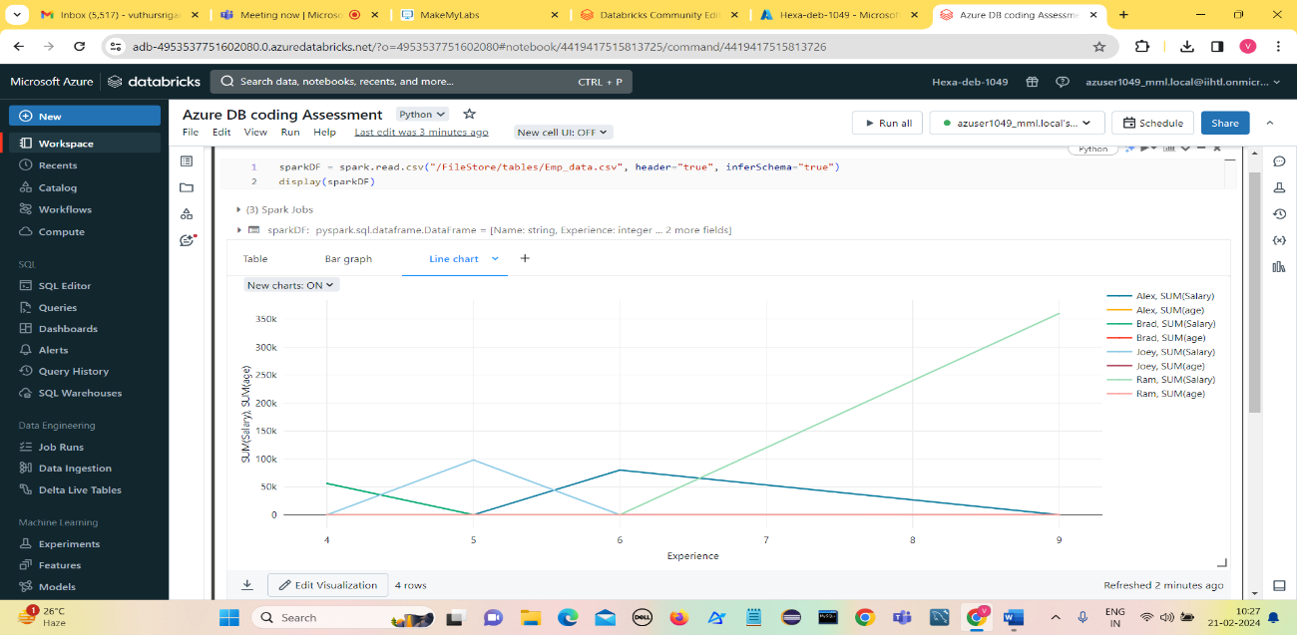**Line chart**
3. 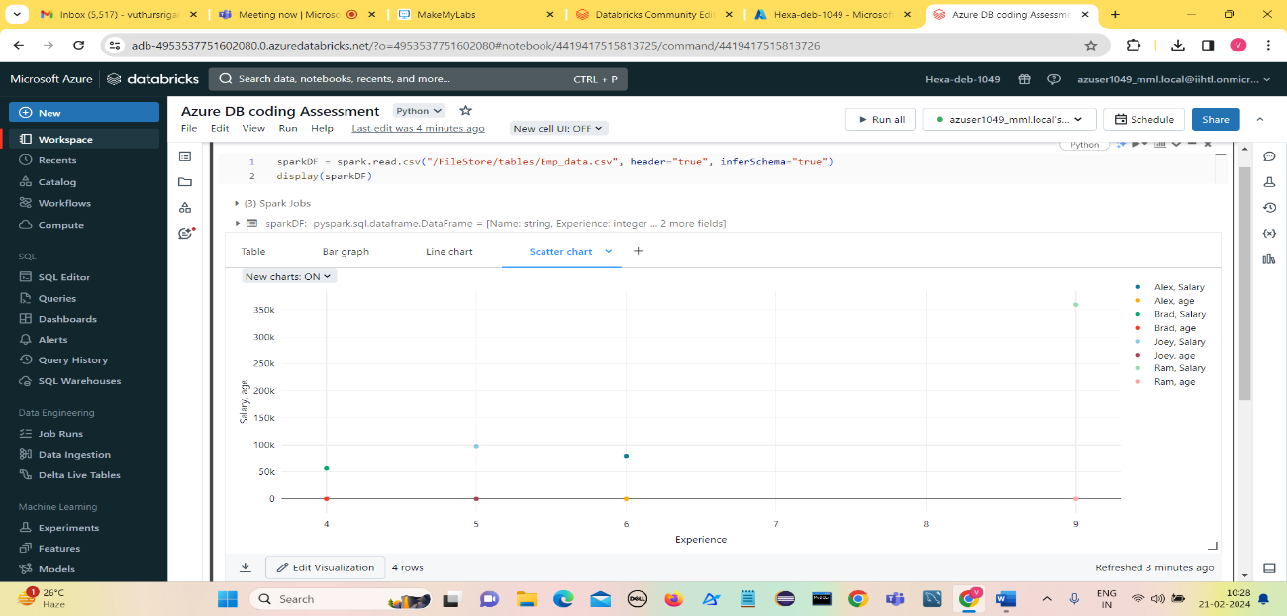**Scatter chart**
4. 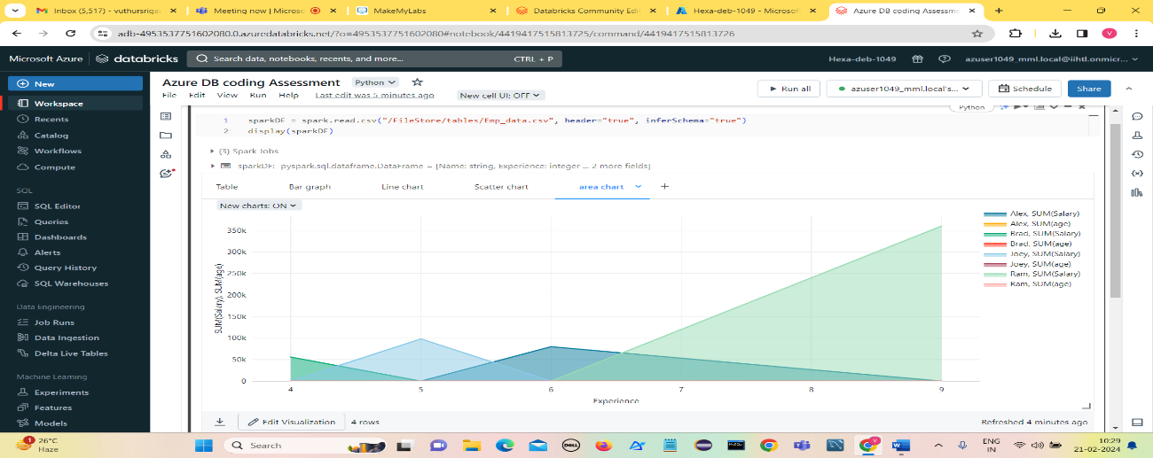**Area Chart**
5. 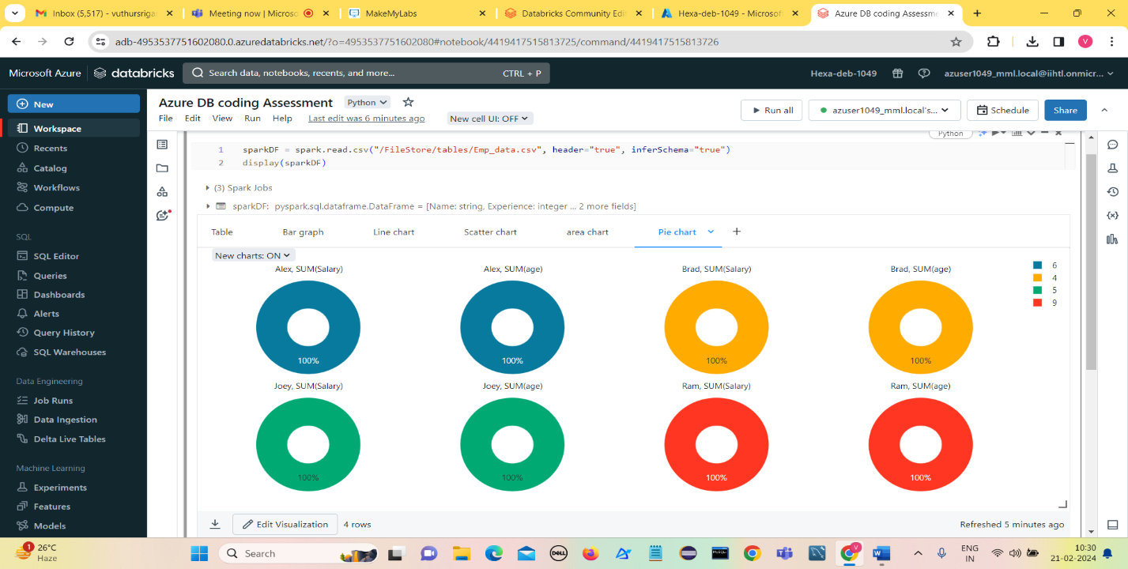**Pie chart**
6. 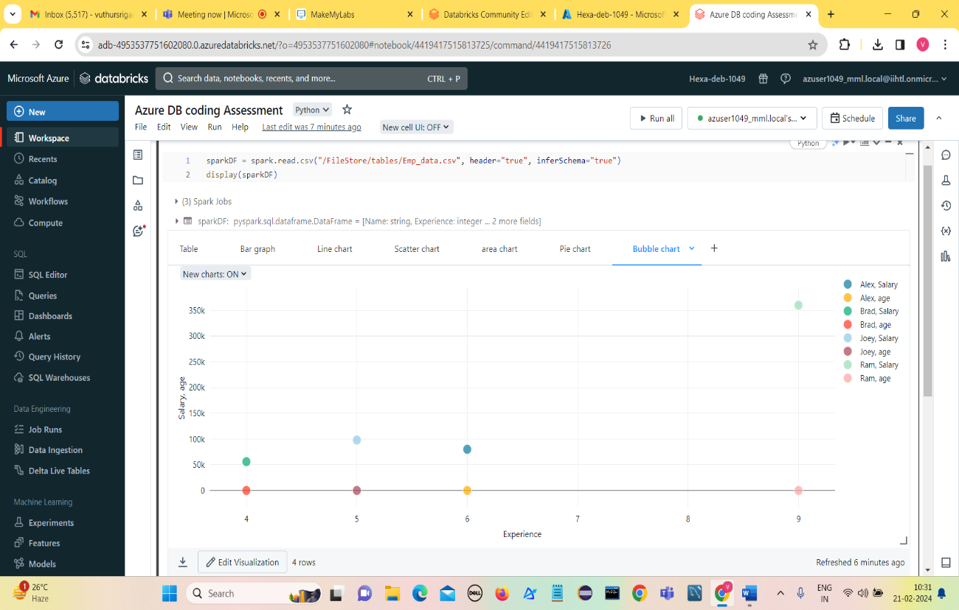**Bubble chart**
7. 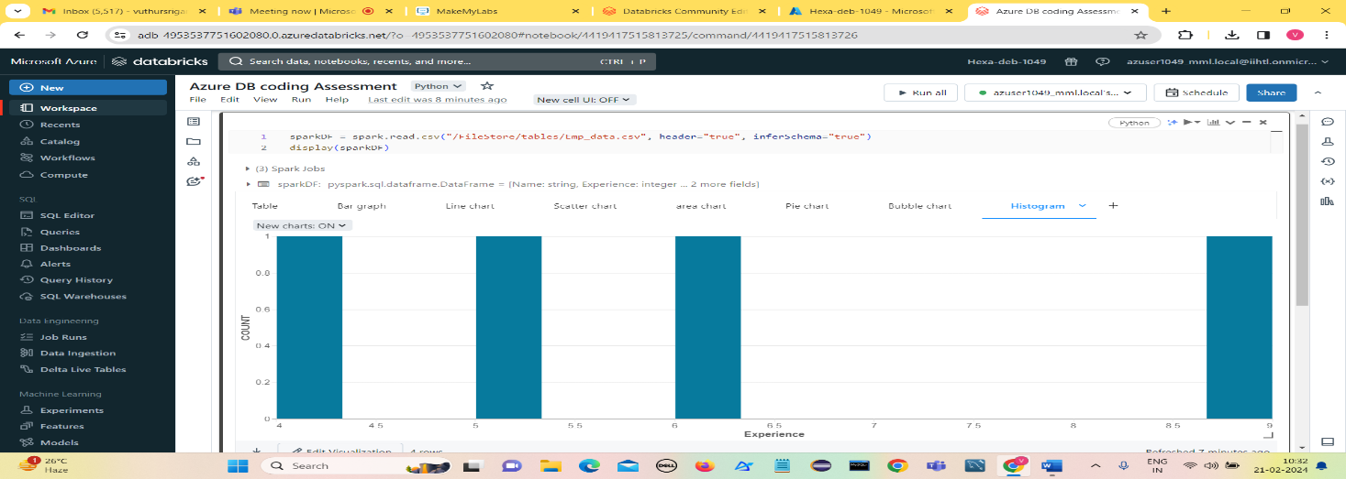**Histogram**
8. 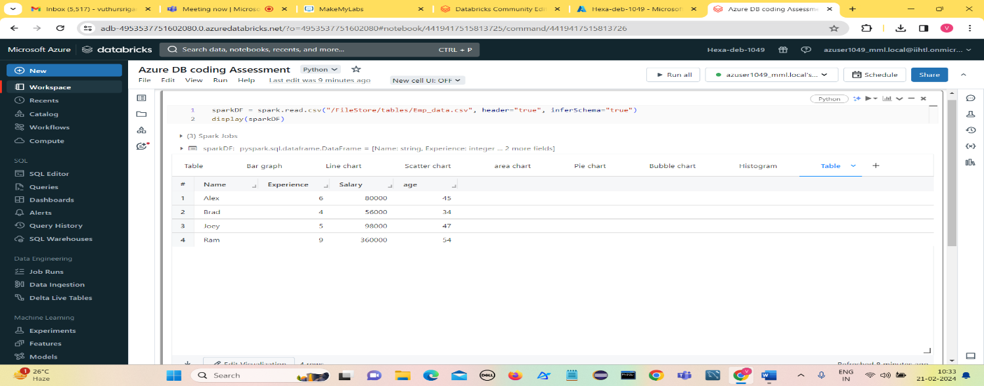**Table**
9. **Data pro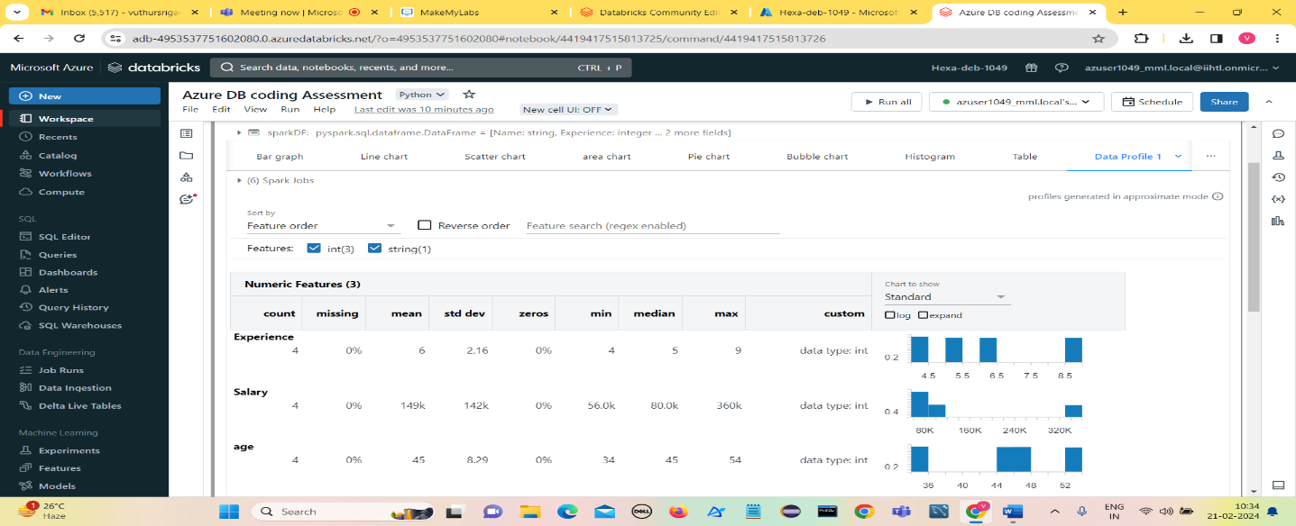file**
10. **Explain Overview of 3 level namespace and creating Unity Catalog objects**.

Unity Catalog provides centralized access control, auditing, lineage, and data discovery capabilities across Azure Databricks workspaces.

**Features of Unity Catalog:**

Unity Catalog possess following features:

1. Define once, secure everywhere
2. Standards-compliant security model
3. Built-in auditing and lineage
4. Data discovery
5. System tables

**Three level Namespace**

A three-level namespace in Unity Catalogue consists of three levels of hierarchy — catalog, schema, and objects. Catalogs are like databases, schemas are like folders or directories, and objects can be tables, views, functions, or other entities.

1. **Catalog:**

* A catalog is the first layer of Unity Catalog’s three-level namespace.
* It’s used to organize your data assets.
* Users can see all catalogs on which they have been assigned the USE CATALOG

Example:

*workspace catalog* (<workspace-name>).

1. **Schema**

* A schema (also called a database) is the second layer of Unity Catalog’s three-level namespace.
* A schema organizes tables and views.We can see all schemas on which they have been assigned the USE SCHEMA permission, along with the USE CATALOG permission on the schema’s parent catalog.
* To access or list a table or view in a schema, use SELECT permission on the table or view.

1. **Objects**

* A table resides in the third layer of Unity Catalog’s three-level namespace.
* It contains rows of data.
* To create a table, we must have CREATE and USE SCHEMA permissions on the schema, and they must have the USE CATALOG permission on its parent catalog.
* To query a table, use  SELECT permission on the table, the USE SCHEMA permission on its parent schema, and the USE CATALOG permission on its parent catalog.
* A table can be managed or external.

**Managed table:**

* Managed tables are the default way to create tables in Unity Catalog
* By default, managed tables are stored in the root storage location
* Managed tables always use the Delta table format.

**External Table:**

* External tables are tables whose data lifecycle and file layout are not managed by Unity Catalog.
* When you drop an external table, Unity Catalog does not delete the underlying data.
* DELTA,CSV,JSON,AVRO,PARQUET,ORC,TEXT.

**Views:**

* A view is a read-only object created from one or more tables and views in a metastore.
* It resides in the third layer of Unity Catalog’s three-level namespace

**Creating Unity Catalog objects:**

Creating Unity Catalog objects involves defining and organizing assets within this three-level namespace.

1. Importing Assests
2. Organizing Assests
3. Creating Catalog objects
4. Accessing Catalog objects

**3 ) Execute & explain, Azure datafactory and its copy activity.**

**Azure Data Factory:**

* Azure Data Factory is a cloud-based data integration service provided by Microsoft Azure.
* It enables you to create, schedule, and manage data pipelines for ingesting, preparing, transforming, and orchestrating data across various sources and destinations.
* Azure Data Factory is a cloud-based data integration service that allows you to create data-driven workflows in the cloud for orchestrating and automating data movement and data transformation.

**Use cases of azure Data Factory:**

* Supporting data migrations
* Getting data from a client’s server or online data to an Azure Data Lake
* Carrying out various data integration processes
* Integrating data from different ERP systems and loading it into Azure Synapse for reporting

**Working of Azure Data factory:**

1. Connect and Collect
2. Transform and Enrich
3. Publish

**Copy Activity:**

* In Azure Data Factory, the Copy Activity is a fundamental component used to move data between different data stores.
* It is one of the activities available within pipelines and is commonly used for simple data movement tasks.

**Steps:**

1. 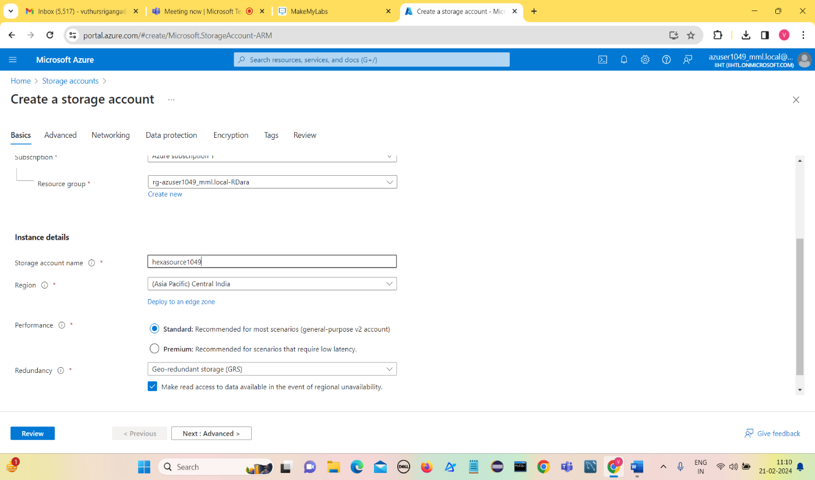**Creating Storage Account (hexasource1049)**

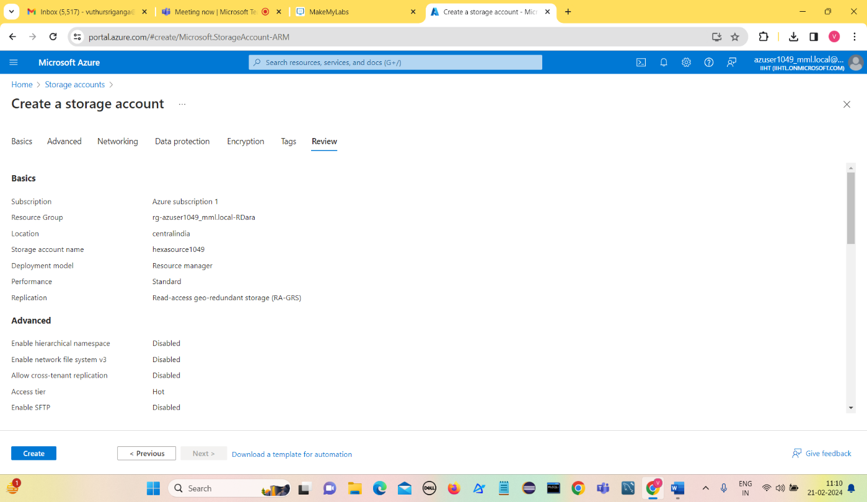**Click on Review**

**Click on Create**

**Deployment is complete**

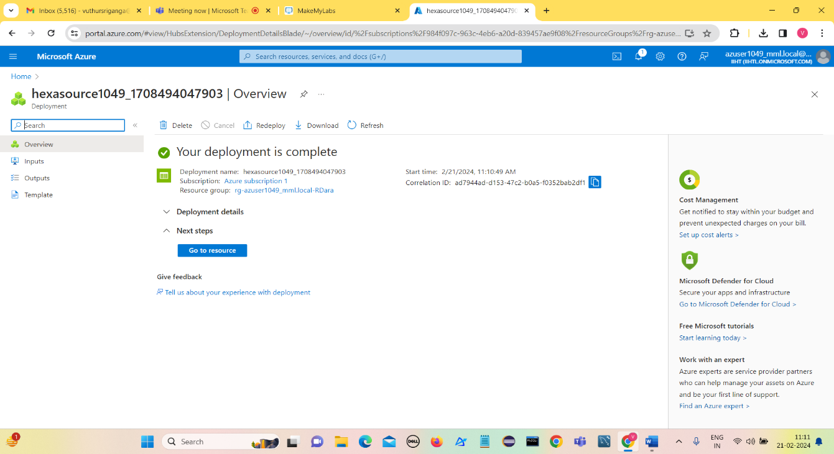

**Click on Go to resource**

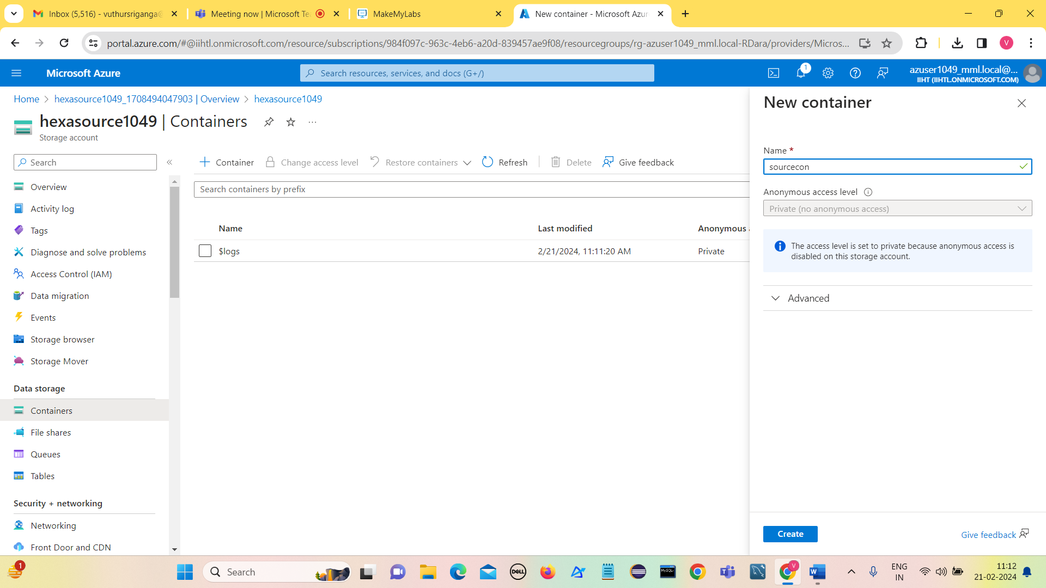

**Creating a container named sourcecon**

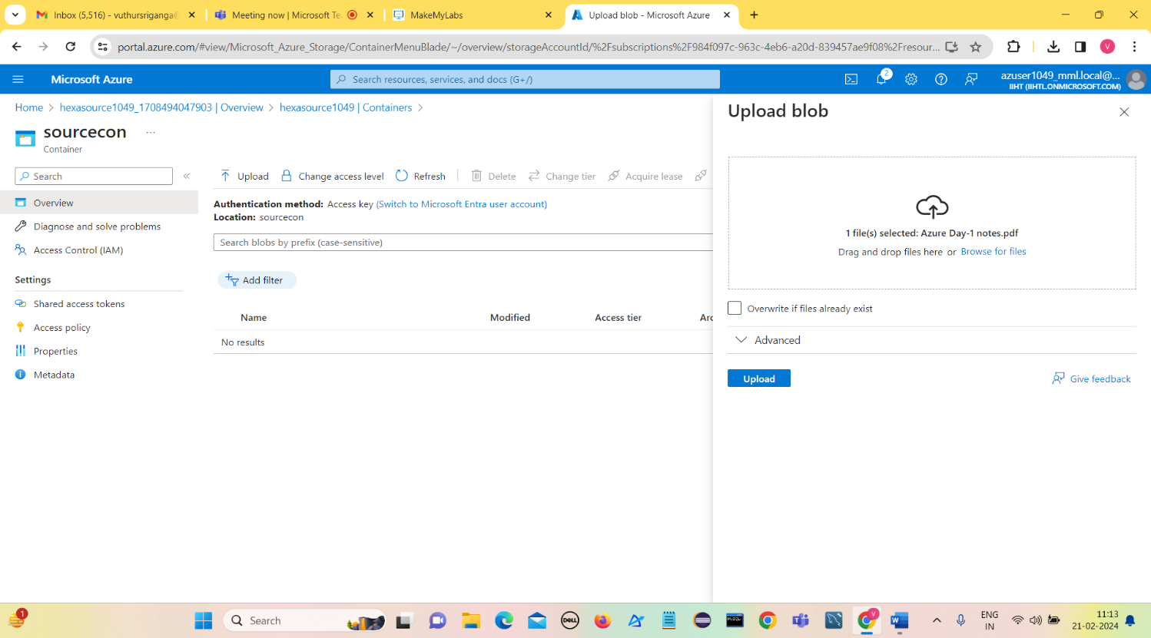

**Uploading a file into source container**

**Click on Upload**

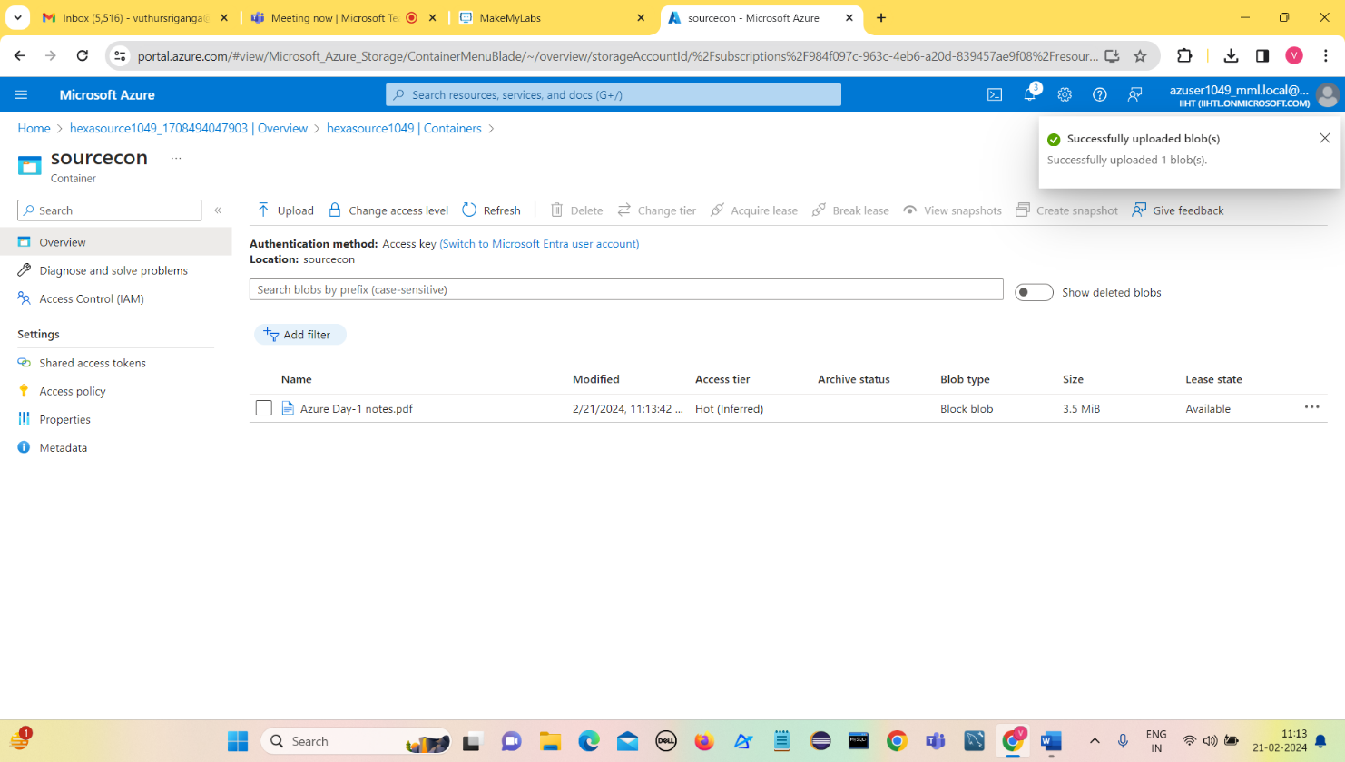

**File named Azure Day-1 notes.pdf is uploaded into sourcecon.**

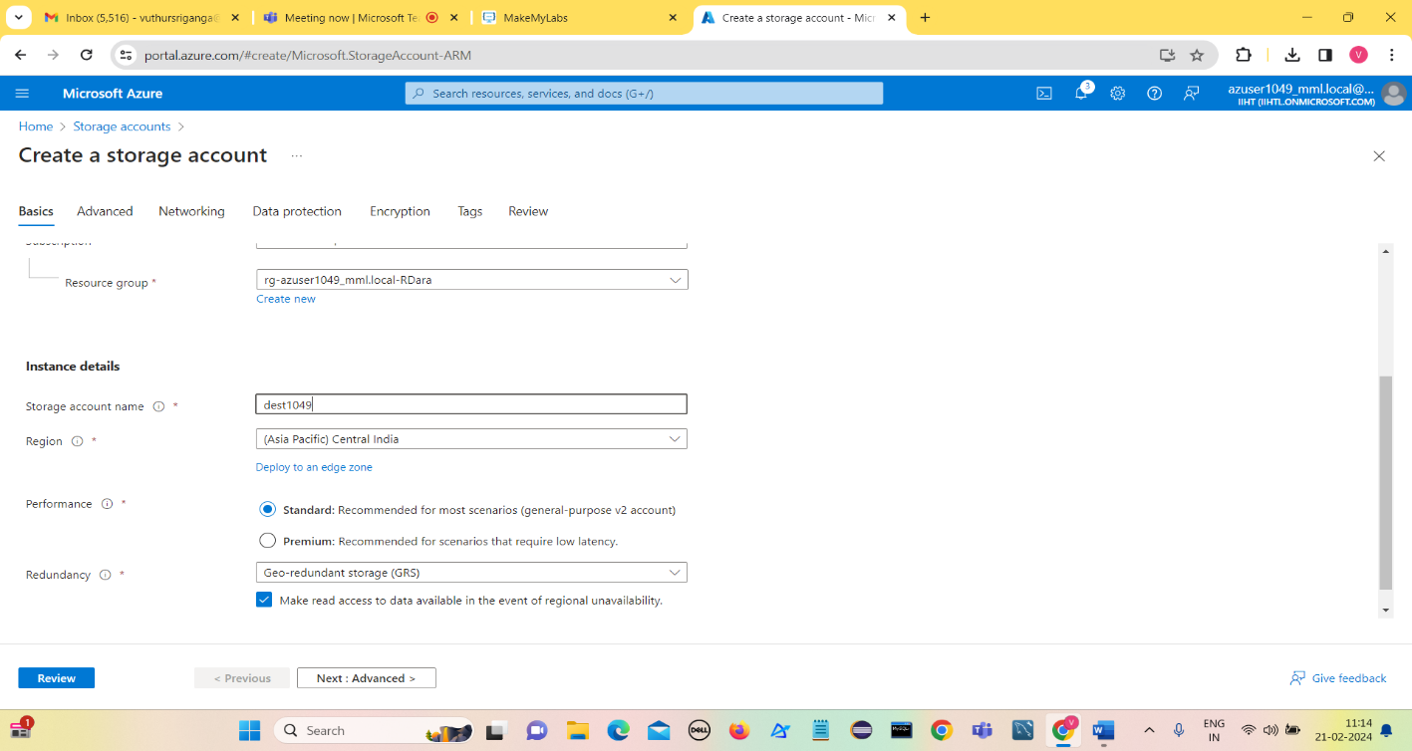**2 ) Create a destination storage account (dest1049)**

**Click on Review and then Click on Create.**

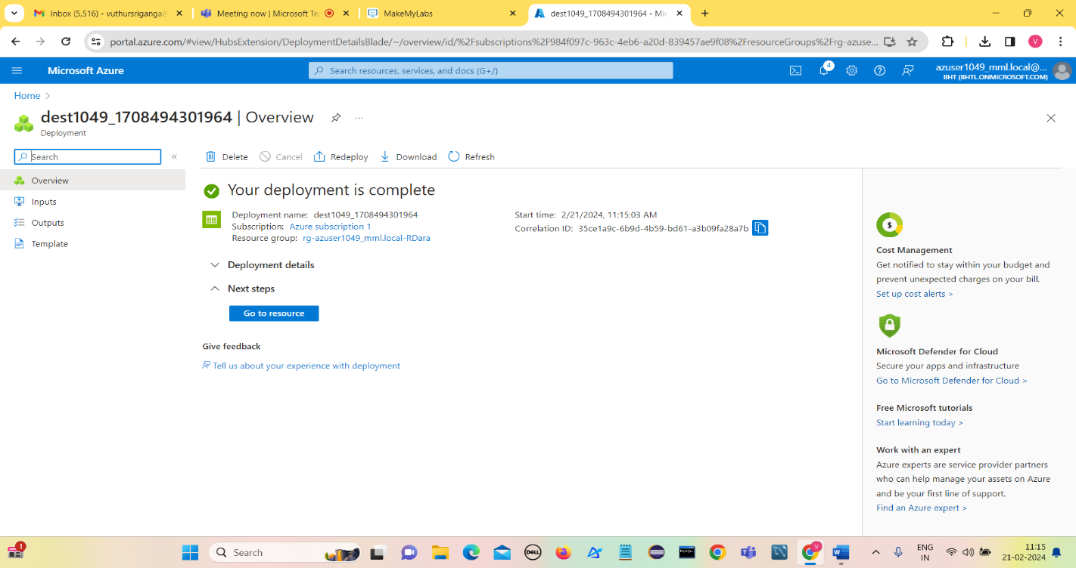

**Deployment is complete**

**Click on Go to Resource**

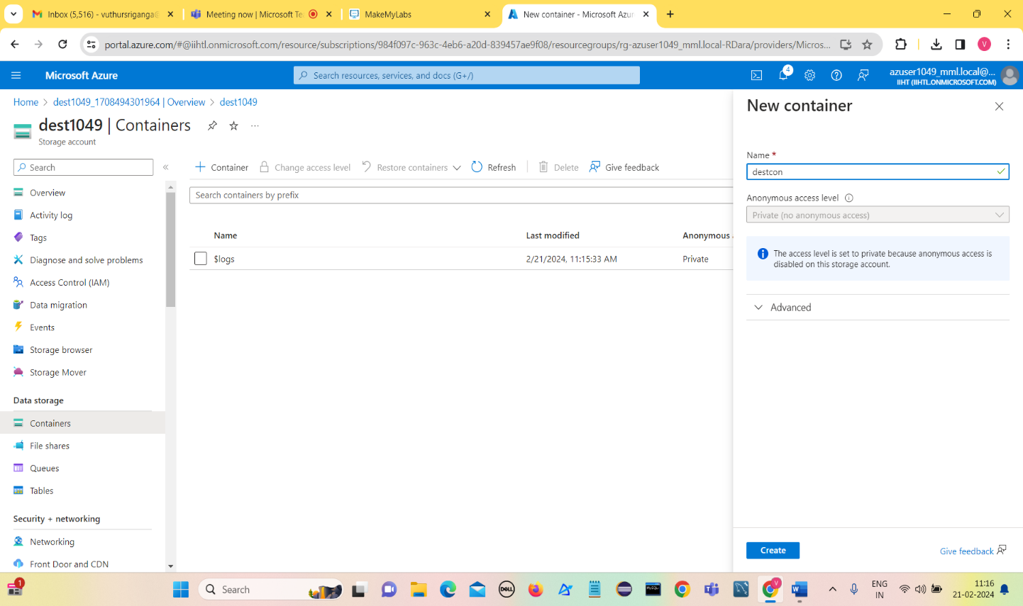

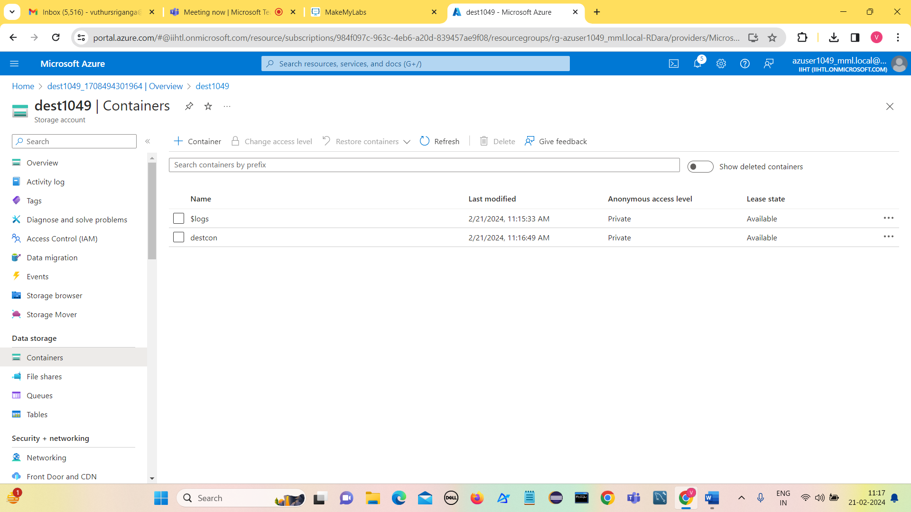**Create a container destcon in dest1049 storage account**

**3 ) Creating a datafactory named hexadatafactory1049**

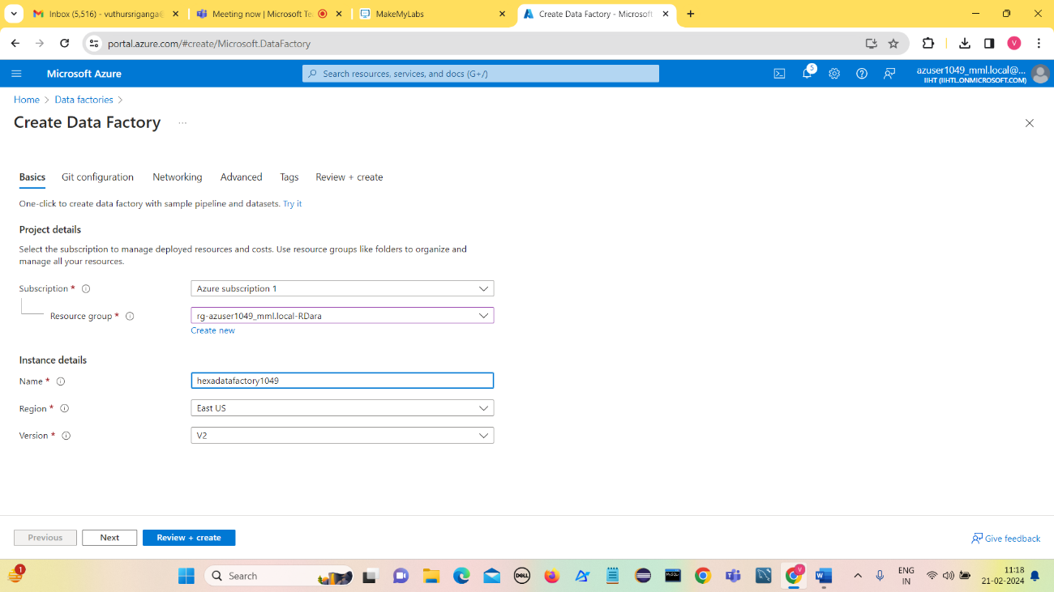**Click on Review+create**

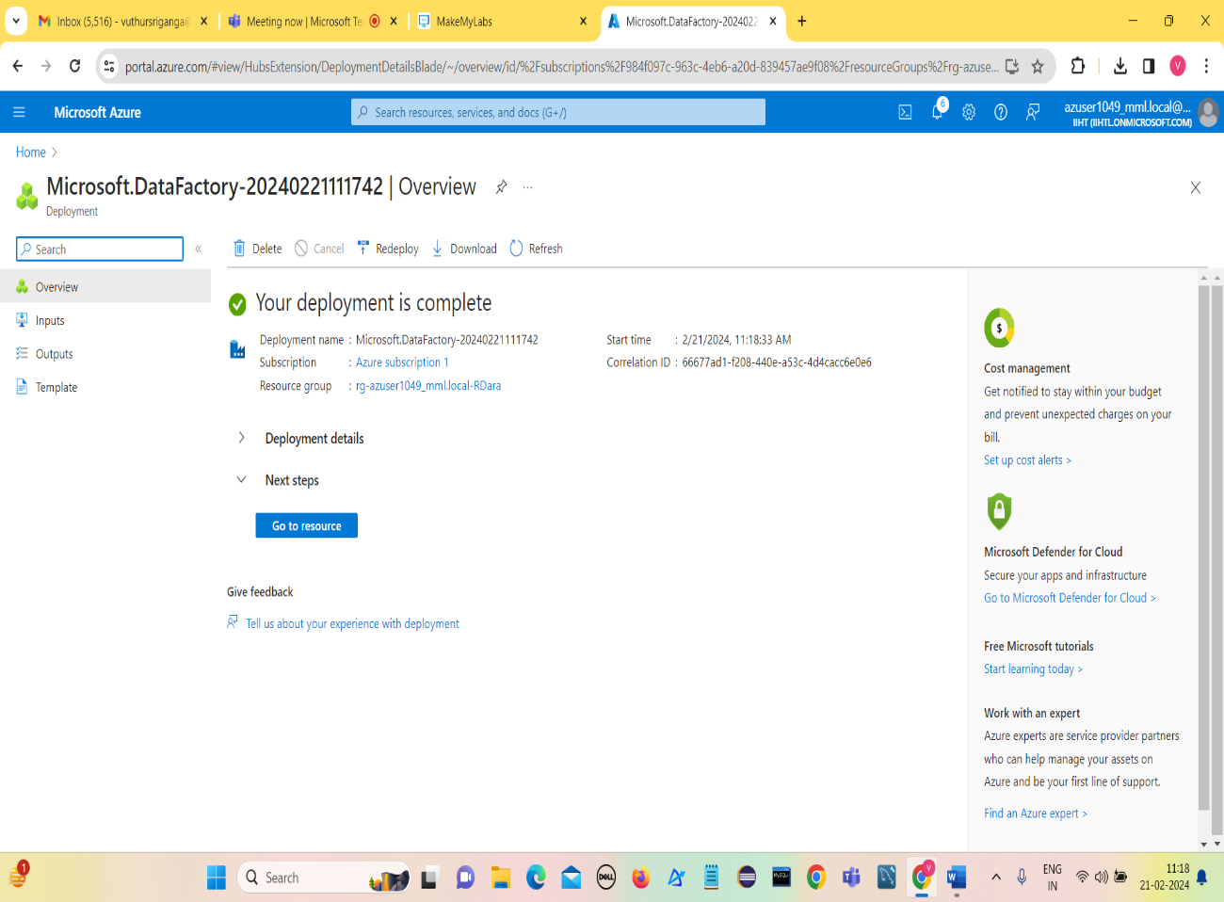

**Go to resource**

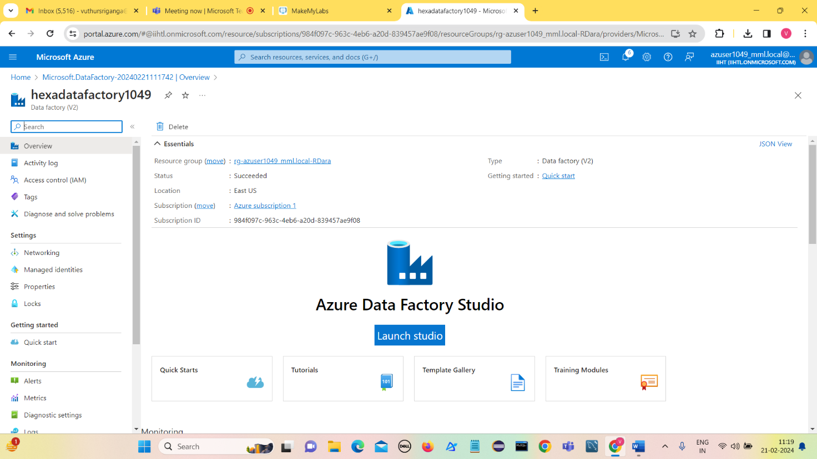

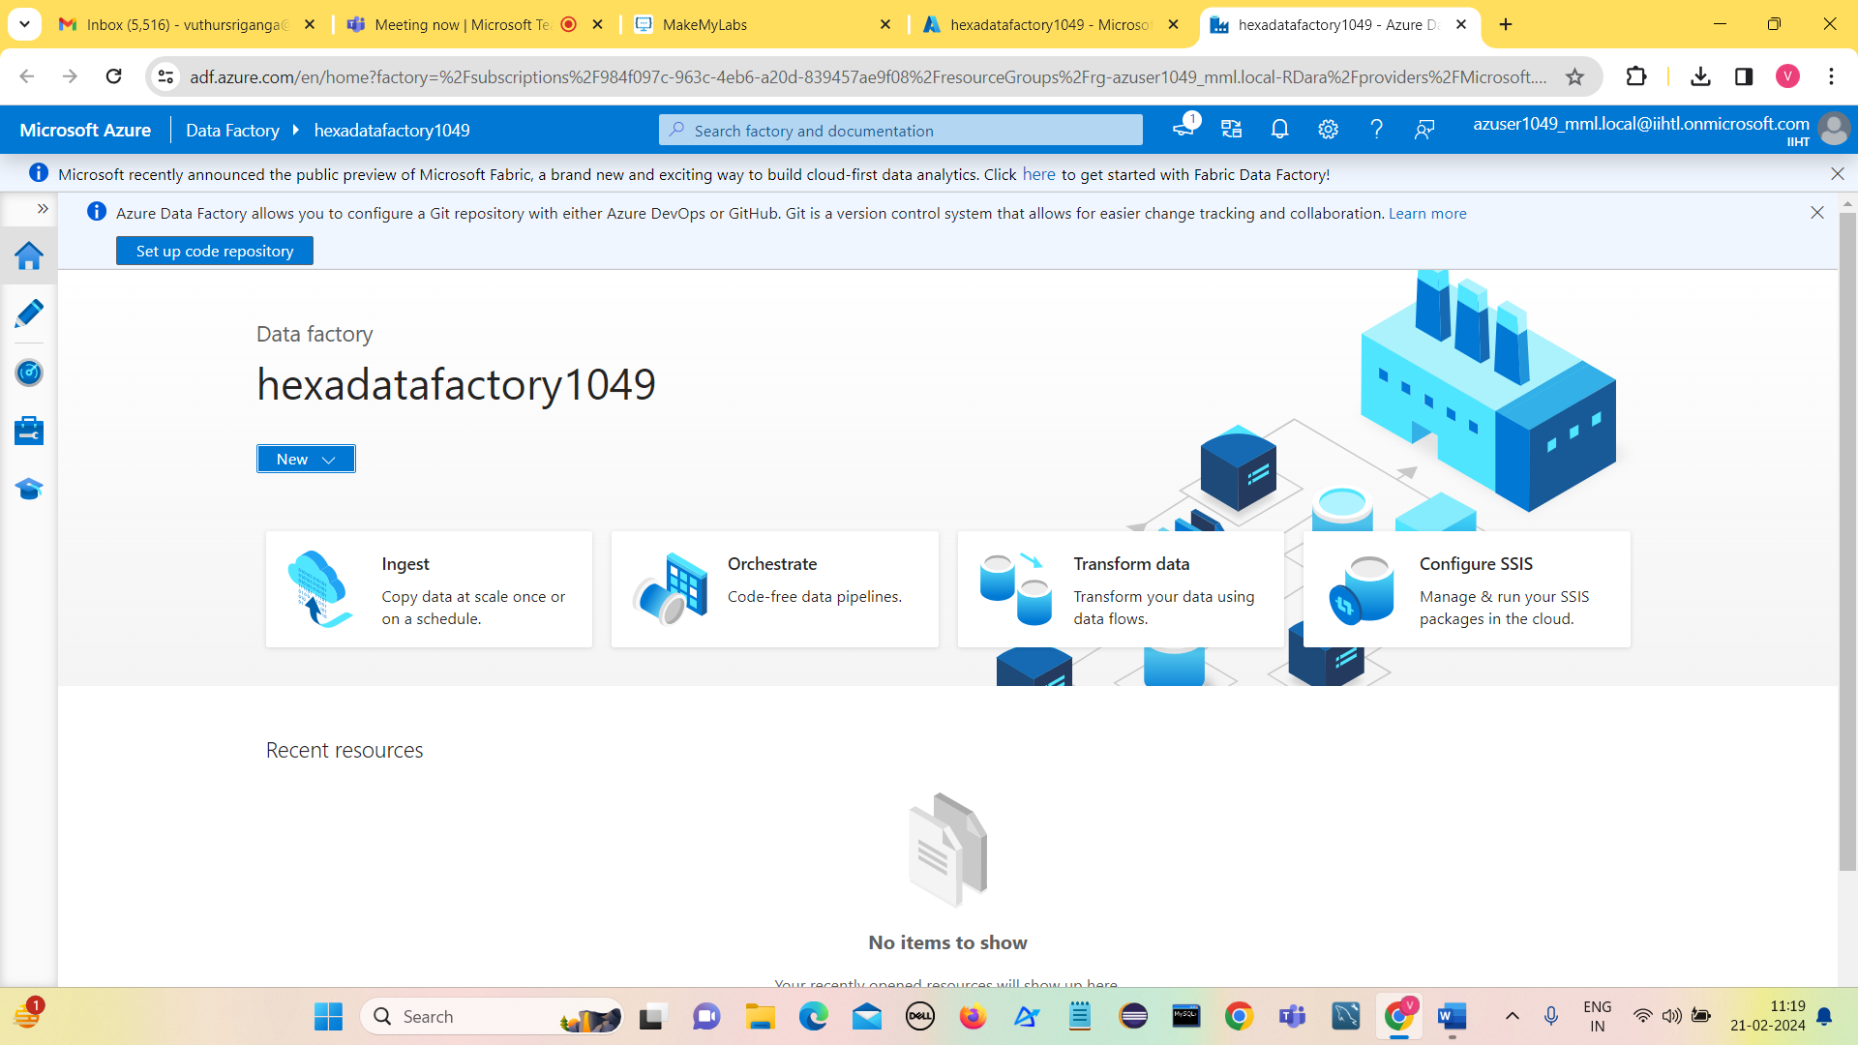**Click on Launch Studio**

**Click on Ingest**

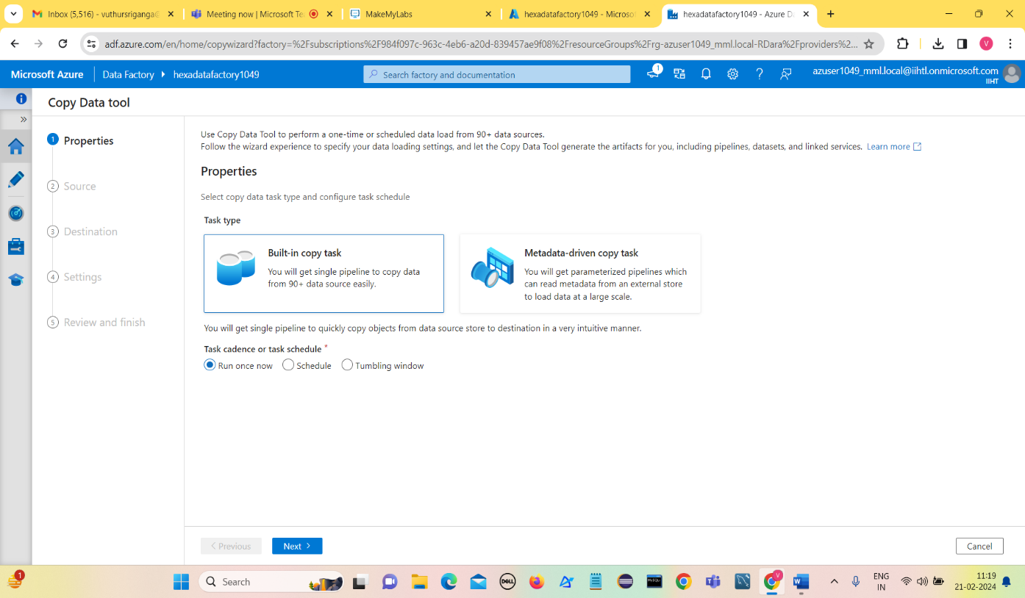

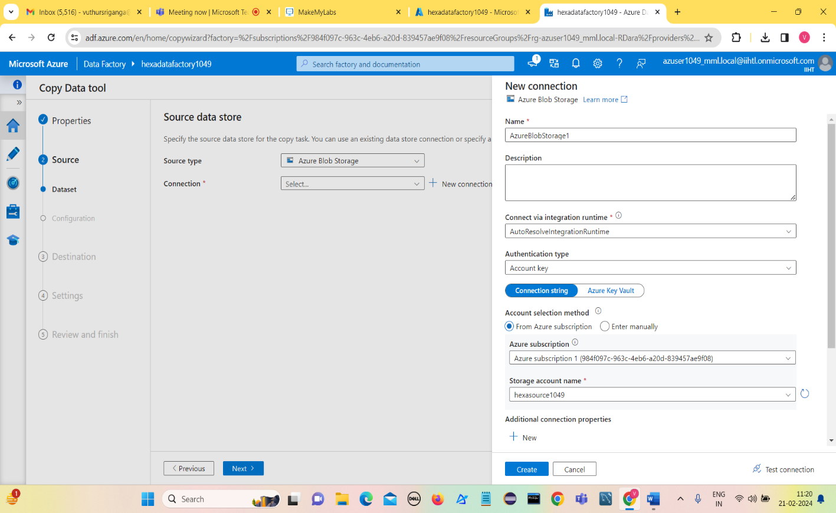**Click on Next**

**Click on Test connection**

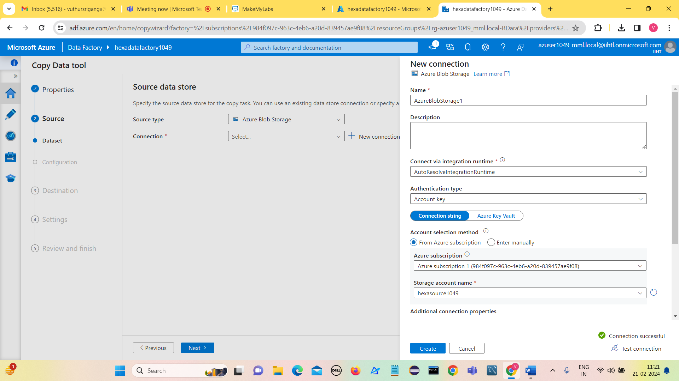

**Connection Successful.**

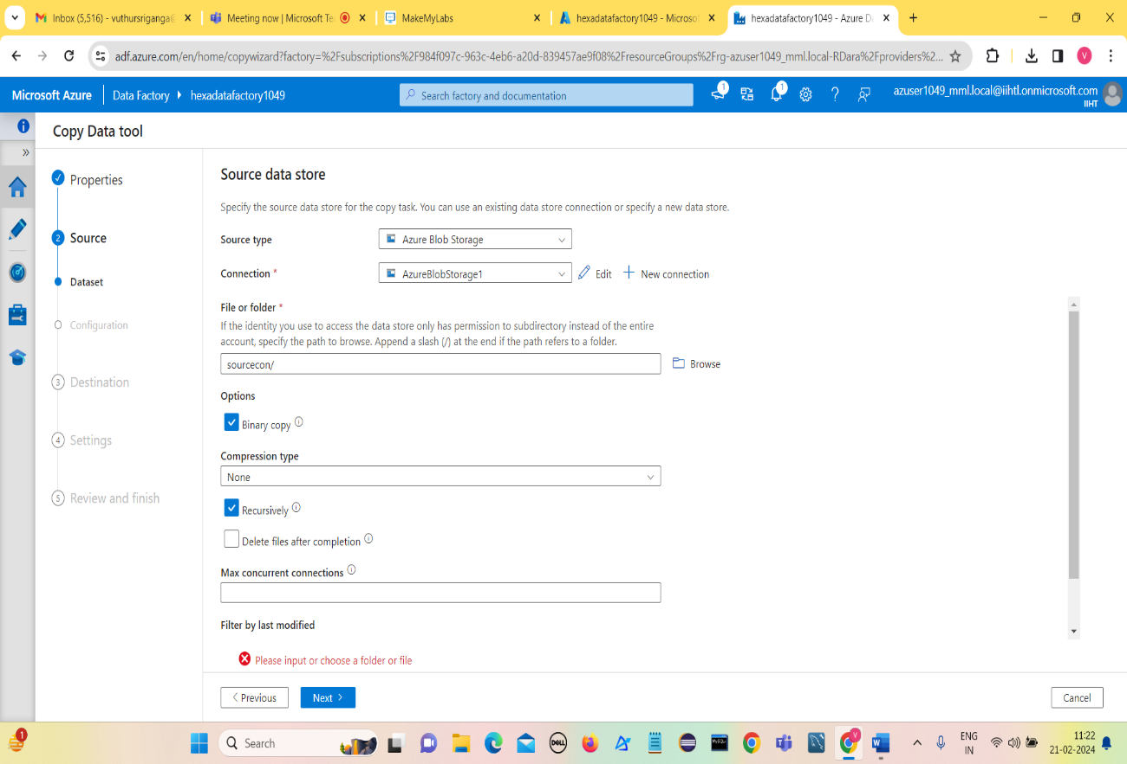**Click on create**

**Click on Next**

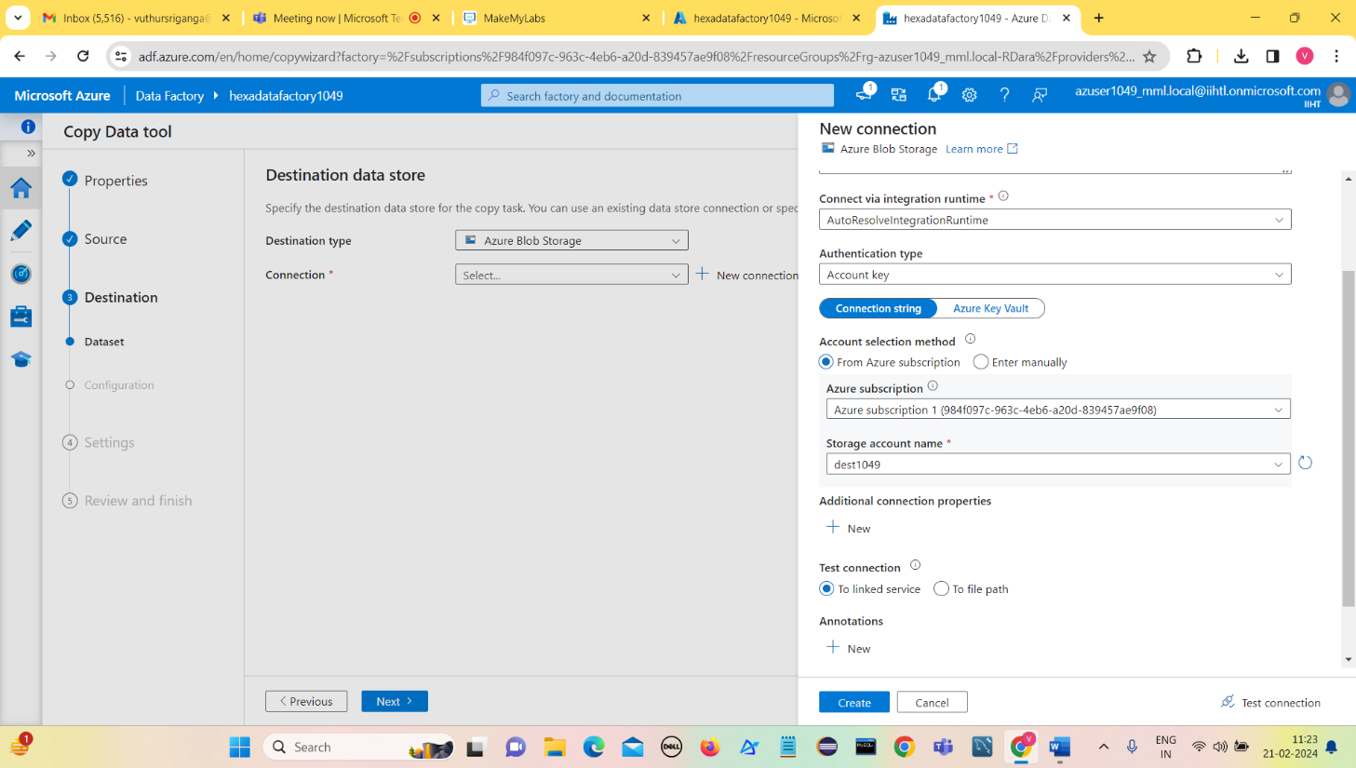

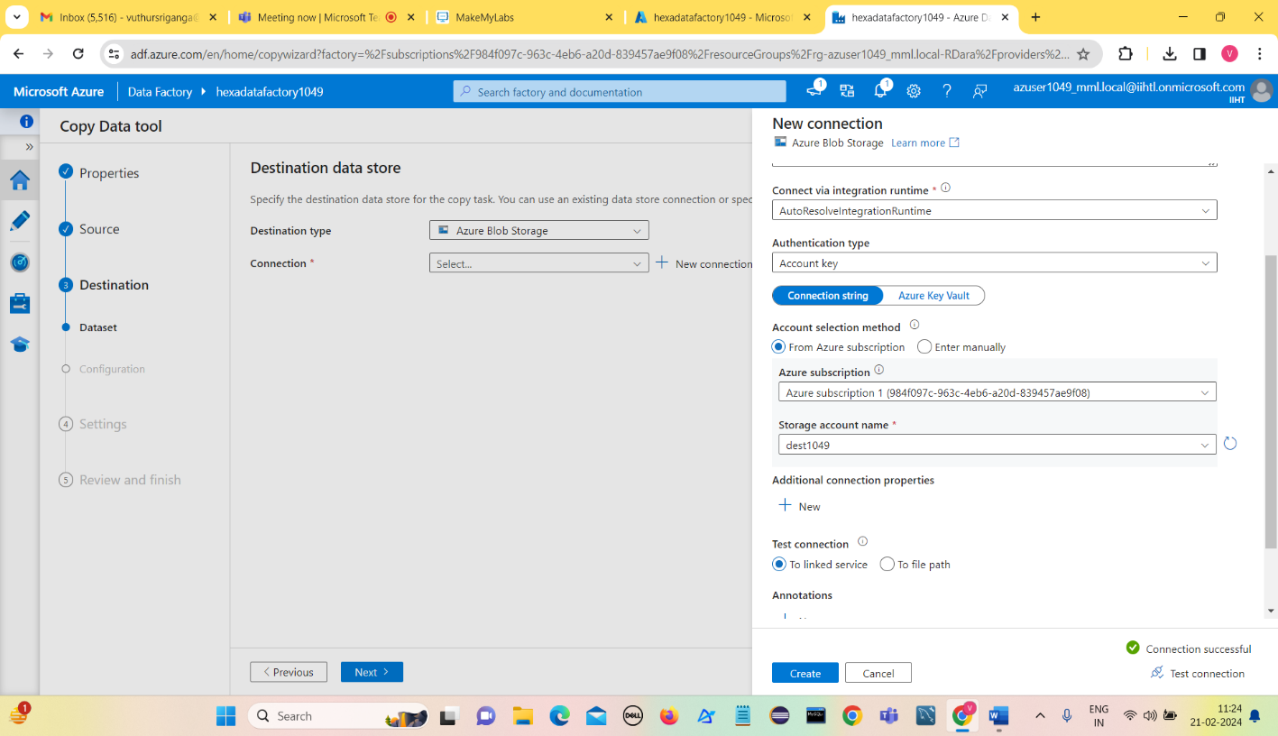**Click on Test connection**

**Test connection successful**

**Click on Create**

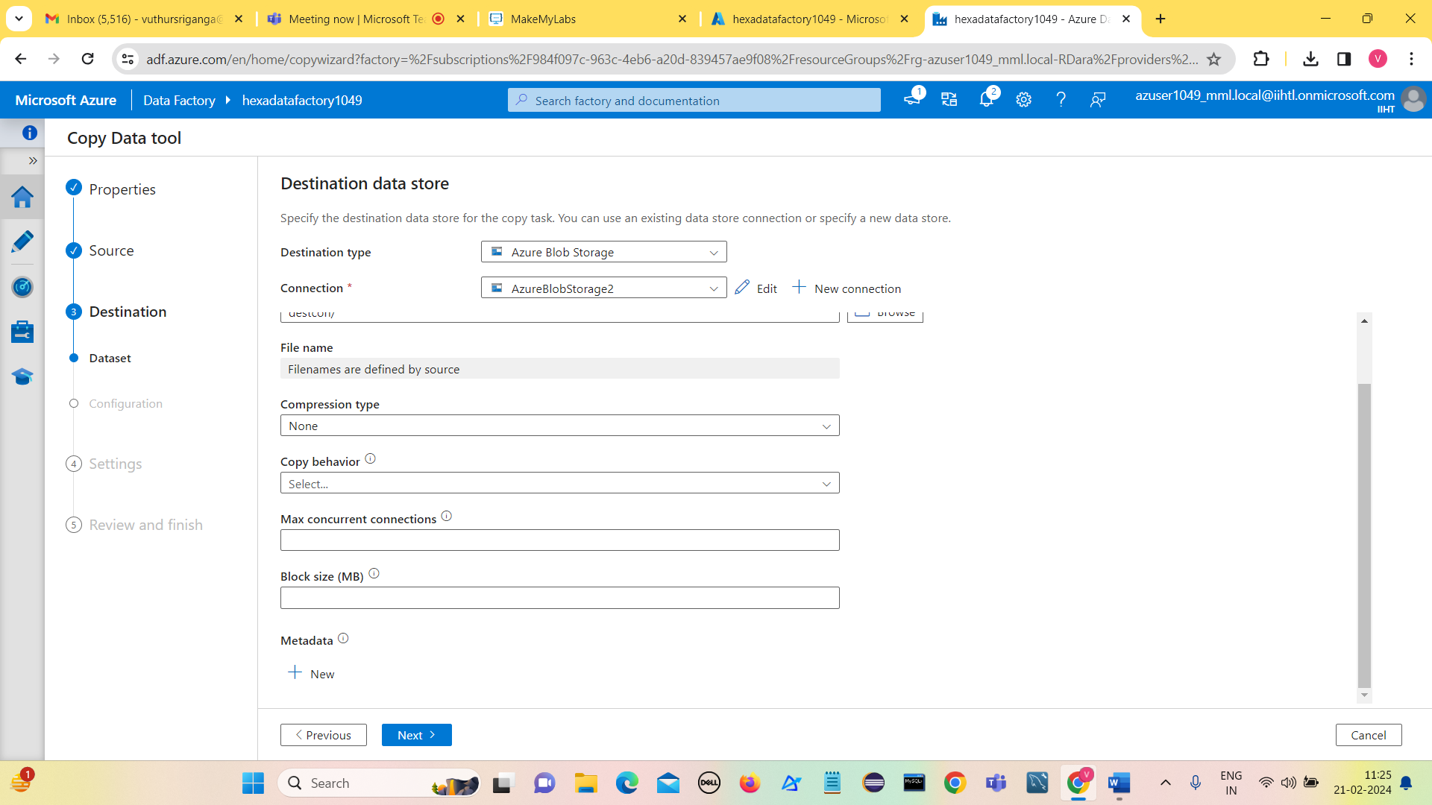

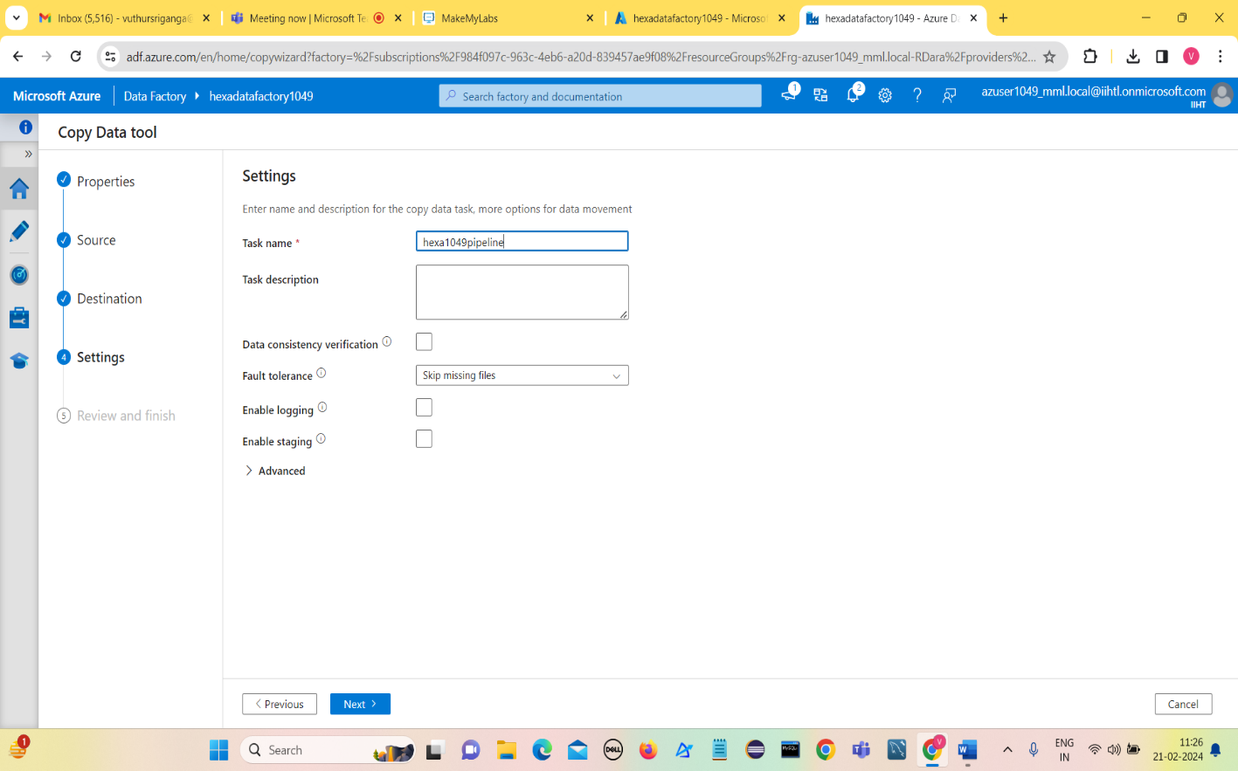**Click on Next**

**Click on Next**

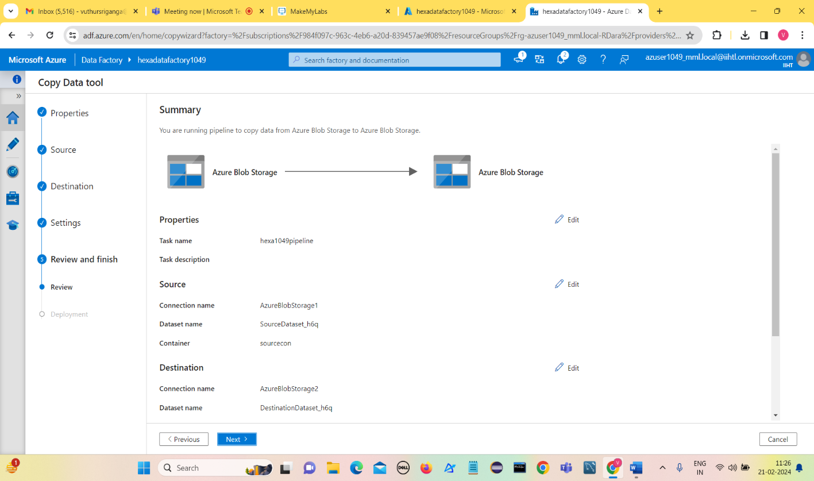

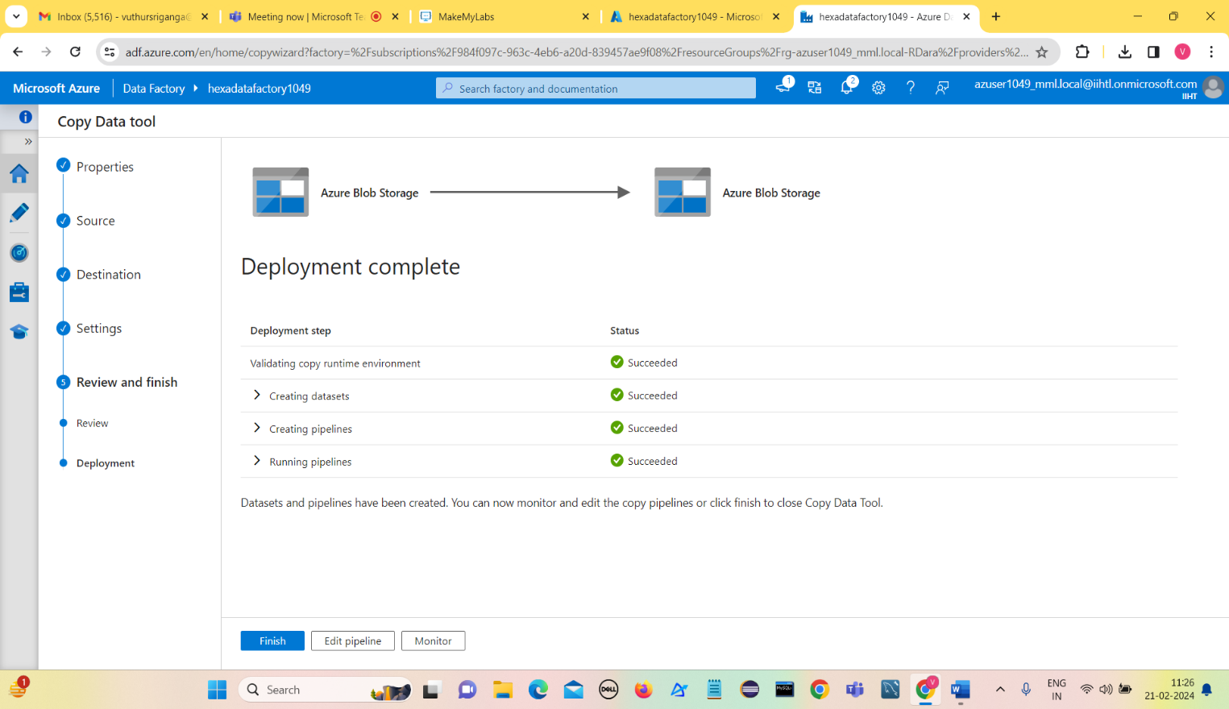**Click on Next**

**Click on Finish**

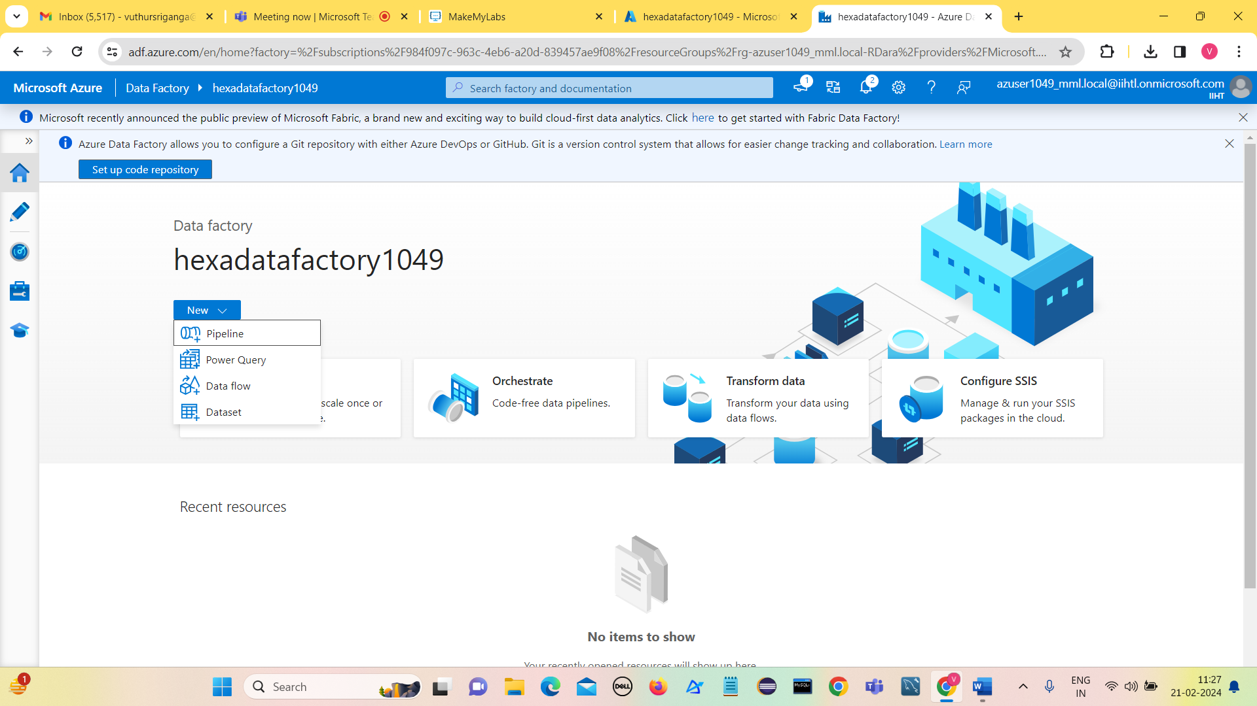

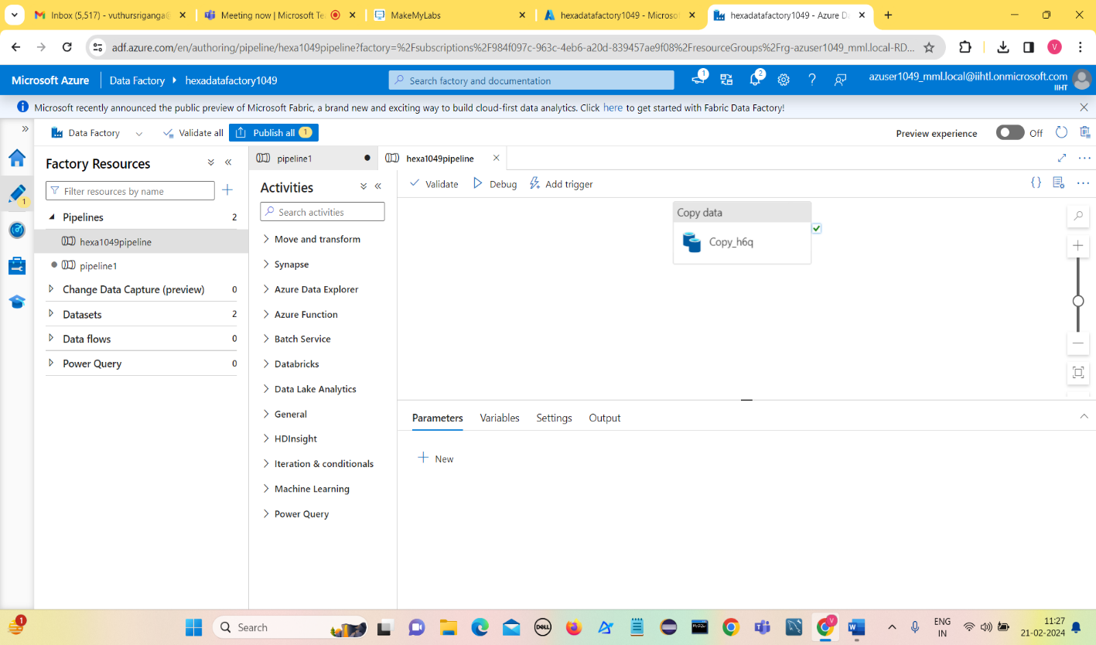**Select pipeline**

**Click on Validate**

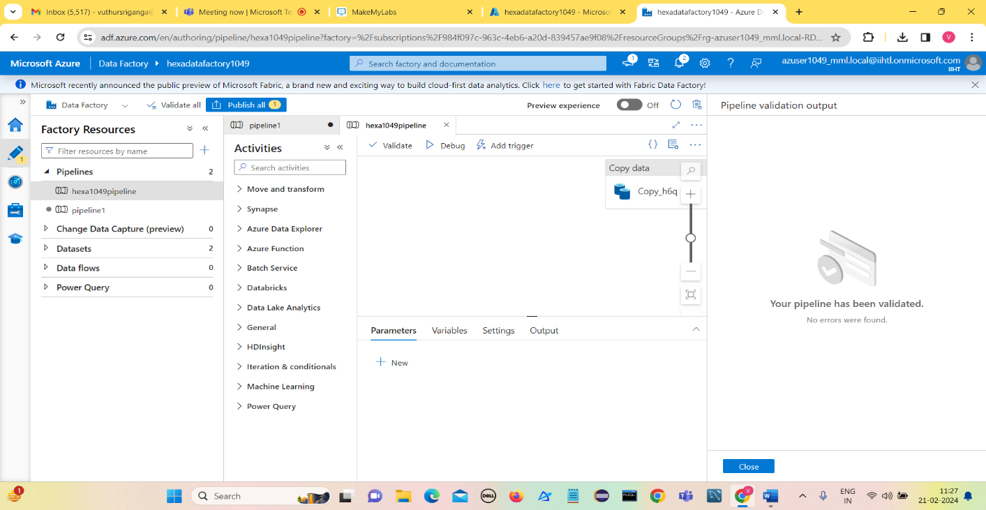**Pipeline has been validated.**

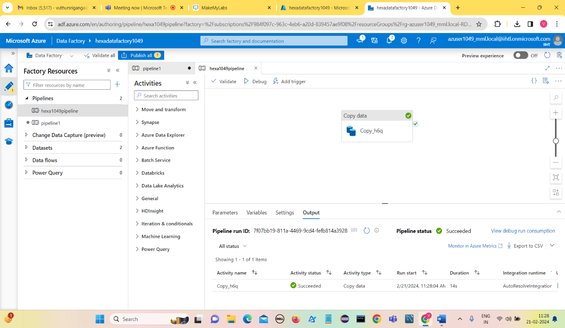**Click on Debug**

**Activity status is succeeded**

**Now go to Destination storage container to check whether file is copied or not.**

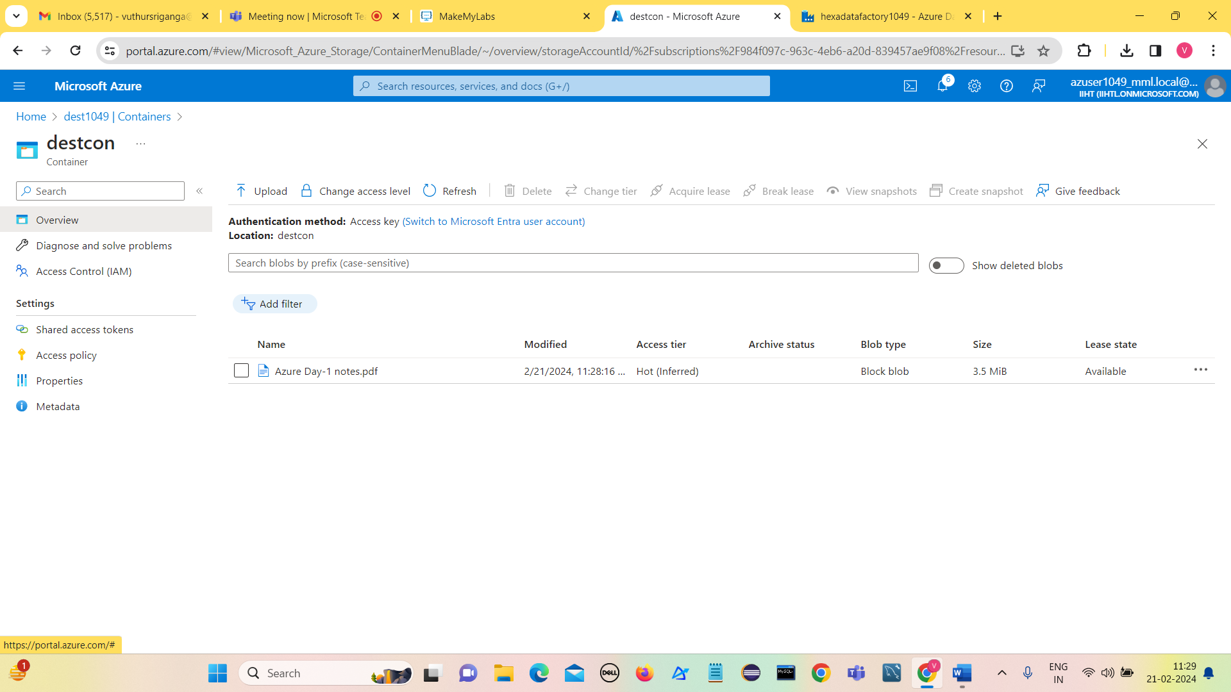

**We can see that file got copied in destination container(destcon) of destination storage container(dest1049)**

**These are the steps that are to be followed for Copy Activity in Azure Data Factory.**

Vuthur Sriganga

Hexaware DataEngineering Batch-1

vuthursriganga@gmail.com